Auckland Seventh-Day Adventist High School | 
Digital Technologies
Internal Assessment
Achievement Standard AS91901
Standard Title: | Apply user experience methodologies to develop a design for a digital technologies outcome
Credits | 3 | Level | 3 | Assessment | Internal
Reference | Digital Technologies | Hangarau Matihiko 3.2

Achieved (A)/ Paetae | Merit (M)/ Kaiaka | Excellent (E)/Kairangi
Apply user experience methodologies to develop a design for a digital technologies outcome. | Apply user experience methodologies to develop an informed design for a digital technologies outcome | Apply user experience methodologies to develop a refined design for a digital technologies outcome.

Level of performance:
Authenticity Statement
Student: I understand that the work I submit for this assessment must be my own. I understand that if it was appropriate to source information, it must be acknowledged appropriately. I understand that I may be required to identify my sources if there is any question about the authenticity of this work. I have acknowledged that plagiarism and/or collusion will result in disciplinary action, which may make me ineligible for a grade in this standard.
Student Name: Rashae Ayala Whanau Class:
Auckland Seventh-Day Adventist High School

Introduction/Kupu Arataki
You will develop some skill research into an area linked to digital technologies; plan and design a digital outcome you will make. The goal is to design your digital outcome. At this time, you will explore User experience methodologies to develop a design.

Task/ Hei Mahi
You will select a theme that you care about, such as the environment, youth mental health, developing safer communities, careers, culture, and heritage. It will be your topic and your own interest. Later you will narrow down your focus and select an issue important to you. To help you choose a good topic, it’s important to first ‘cast the net wide’ and explore the topic from many angles.
You will be following a path to develop your design based on the inquiry outcome that you proposed in your inquiry assessment. Explaining the purpose of the digital technologies outcome and the requirements of the end user, applying user experience methodologies to generate a range of design ideas. You will find detailed information for each task at www.sites.google.com/view/dte-robotics/seniors/year-13

Auckland Seventh-Day Adventist High School |  |  | 
Apply user experience methodologies to develop a design for a digital technologies outcome involves. |  |  |  | A
A1 | Explaining the purpose of the digital technologies outcome and the requirements of the end users | Student has explained purpose, end users and requirements.
A2 | investigating relevant user experience methodologies | The student has undertaken research about User experience methodologies.
A3 | applying user experience methodologies to generate a range of design ideas | here is evidence of users experience methodologies applied.
A4 | explaining the appropriateness of a chosen design | Student has selected a design and explain the appropriateness of it.
A5 | modelling and testing the design idea | Students include feedback and testing of their design.
A6 | explaining relevant implications | The student has explained and addressed relevant implications.
Refine a digital technologies outcome involves |  |  |  |  | M
M1 | effectively using data gained from modelling and user testing to improve the design | Student has used the feedback to improve their designs.
M2 | evaluating how user experience methodologies were used in developing the chosen design | Student explain how UX were used to develop their design.
M3 | evaluating how the chosen design addresses relevant implications | The student has evaluated relevant implications in their designs.
Enhance a digital technologies outcome involves |  |  |  |  |  | E
A1 | justifying the choice of user experience methodologies used to develop the chosen design | Student Justify the user experience methodologies used to develop their design.
A2 | justifying that the chosen design is suitable for the purpose and end users | The student has justified their design for purpose and end users.
A3 | justifying how the chosen design might be further developed in the future. | The student has justified how the design might be further developed in their future.
Final grades will be determined on a holistic examination of the evidence provided against the criteria in the achievement standard.

Comments:

Digital Technologies – DTE3U - AS91901

Apply user experience methodologies to develop a design for a digital technologies' outcome.
Part 1: Explain the purpose of the digital technologies’ outcome and the requirements of the end-users.
The purpose of creating a website on mental health and people pleasing is to provide a network for teenagers aged 15-19 that raises awareness about people-pleasing and its impact on the mental health. As a teenager within that age group, I often find it difficult to say no to others and tend to prioritise other people's needs and opinions over my own. Just recently I came to know that it is known as people pleasing and I never knew it was a feeling because I thought it was just part of hospitality and normal since I grew up in a big family. The struggle of saying no to people and becoming a people pleaser made it hard for me to focus on my own wellbeing and had a negative impact on my mental health, which lead to stress, anxiety, and feeling overwhelmed all the time. After realising this and asking others, many teenagers experience this similar pressure from friends, school, and social media. Where they felt the need to either fit in or gain approval from others not just in this society but also within our own families. However, for this issue there is limited resources available where it is safe to talk about this issue, or having a supportive and accessible space to find information

PMI TABLE
 | Positive | Minus | Interesting
Mental Health Foundation  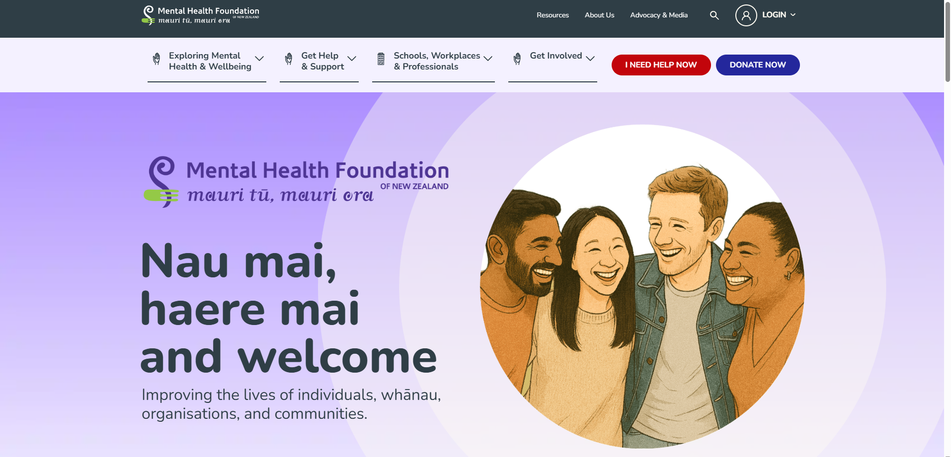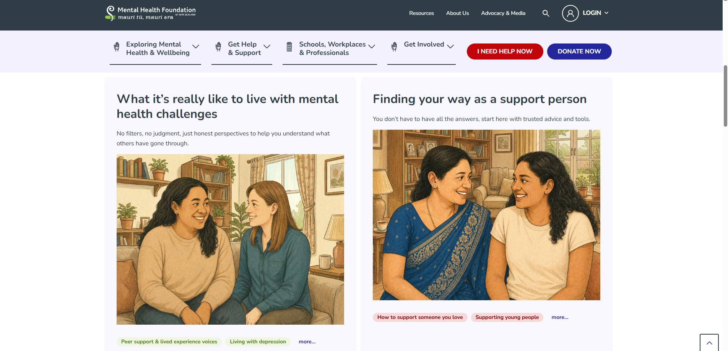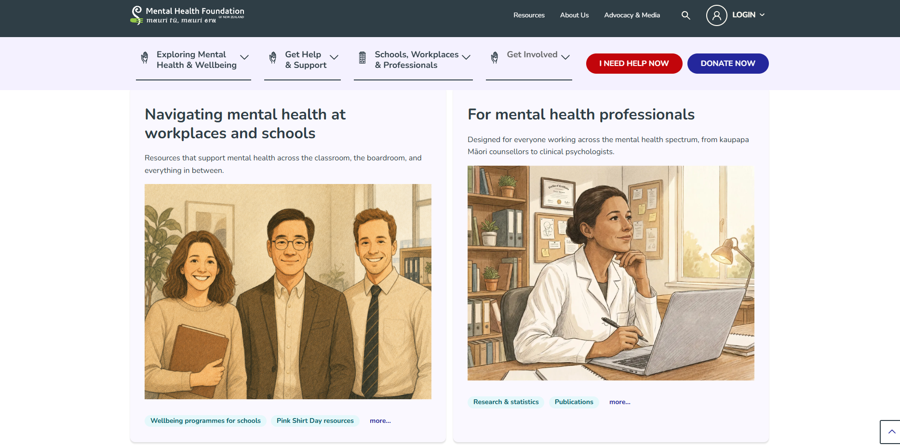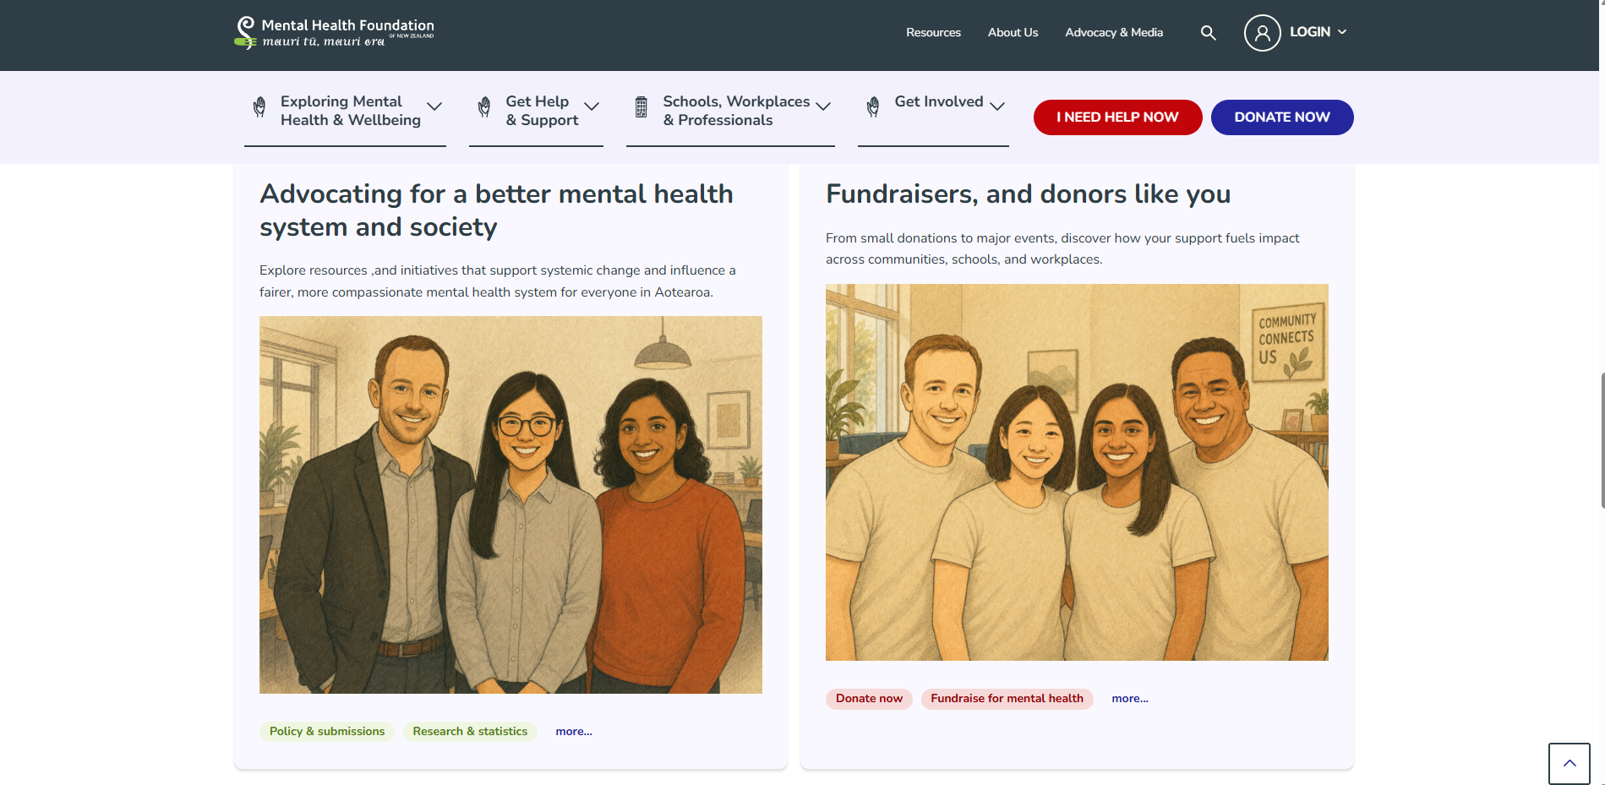 | - It's a trusted New Zealand source (relevant to local teens aged 15-19)  - Explains what some mental health issues are such as stress, anxiety, and pressure are  - Provides helpful ways to cope  - The information is clear and nicely structured  - It covers the emotional wellbeing in school and social life  - Encourages teenagers or users to seek help and support when needed  - I like the way it uses a lot of images to catch the user's attention | - It isn't specifically focused on people pleasing behaviour  - The information can feel too general for older teens  - The style of the website is quite formal and less engaging for teens  - Not enough real-life teen scenarios or testimonies. | - I want to create simple explanations of people pleasing and mental health  - Add strategies on how to cope with people pleasing (e.g., saying no, managing stress, etc...)  - Include a support/help section for teens in NZ  - Make information easy to understand for ages 15-19  - And focus on the mental health awareness + education
Youth Line  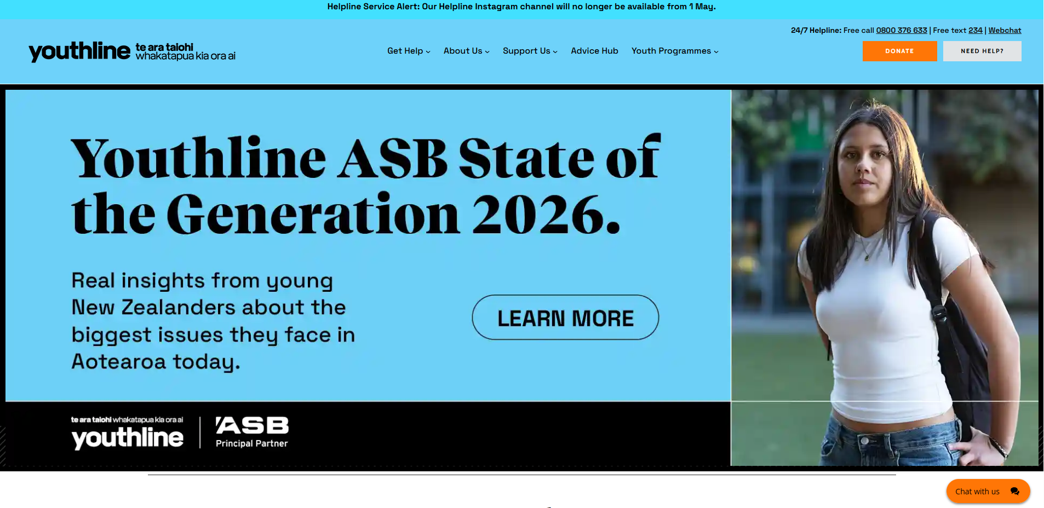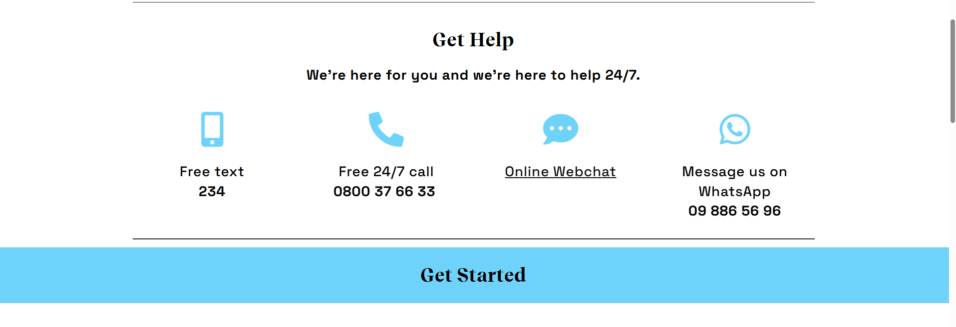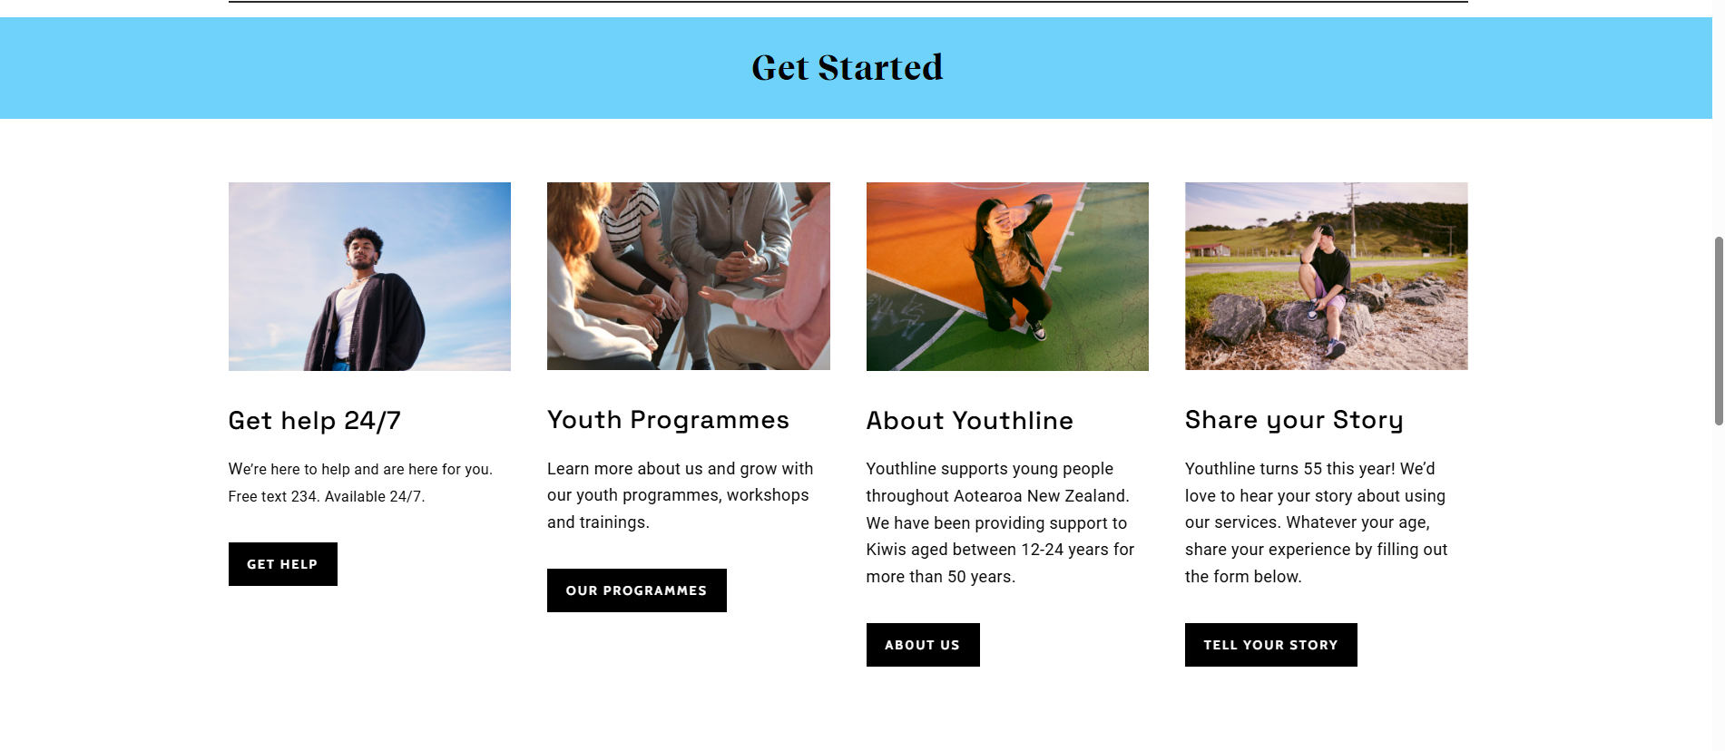 | - This website is specifically made for young people aged 12-24 but also very relevant to teens aged 15-19.  - It uses friendly, relatable languages  - Uses other real support such as a section where it provides (text, phone, online chat)  - Focusses on issues like pressure, relationships and emotions  - Really easy to navigate and understand | - It doesn't explain people pleasing in depth  - It is more focused on providing support not the educated side  - Limited details on psychological information's.  - Less information about the causes of behaviour  - Not many structed learning sections | - Use a teen-friendly tone where it feels relatable not too formal  - Include real like scenarios like friends, school, relations, family, etc  - Add a “get help” section with support options  - Make the website safe and supportive  - And focuses on teen experiences ages 15-19
Headspace  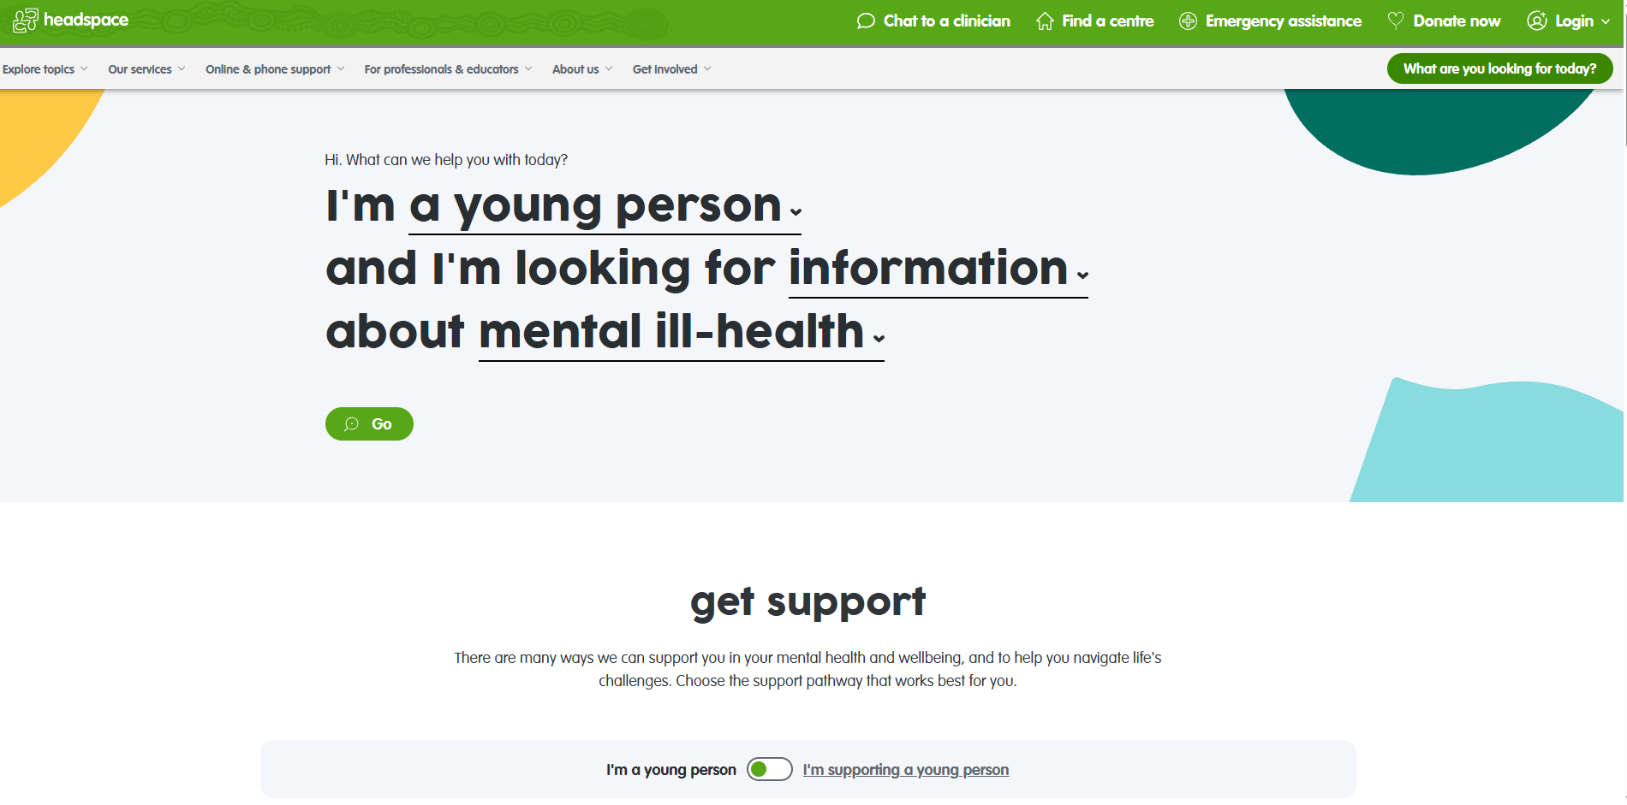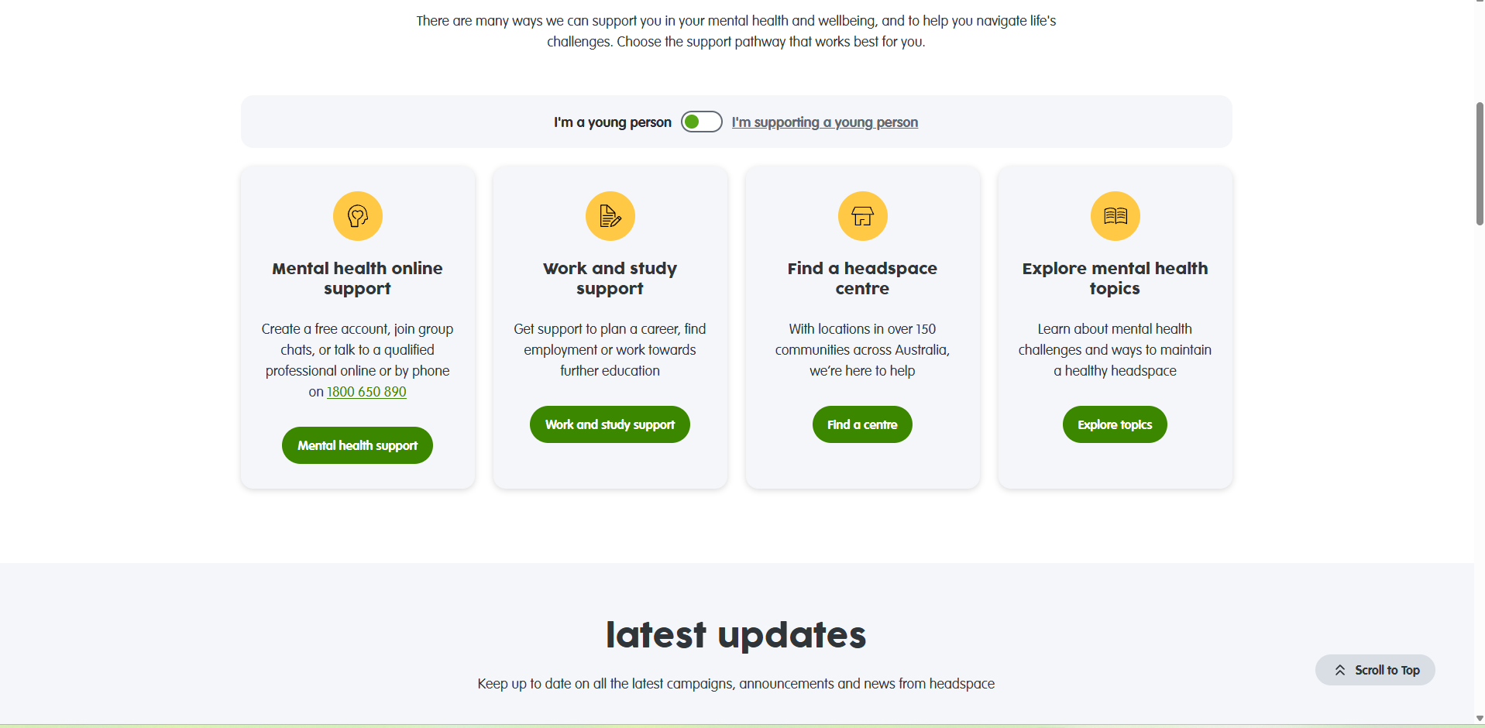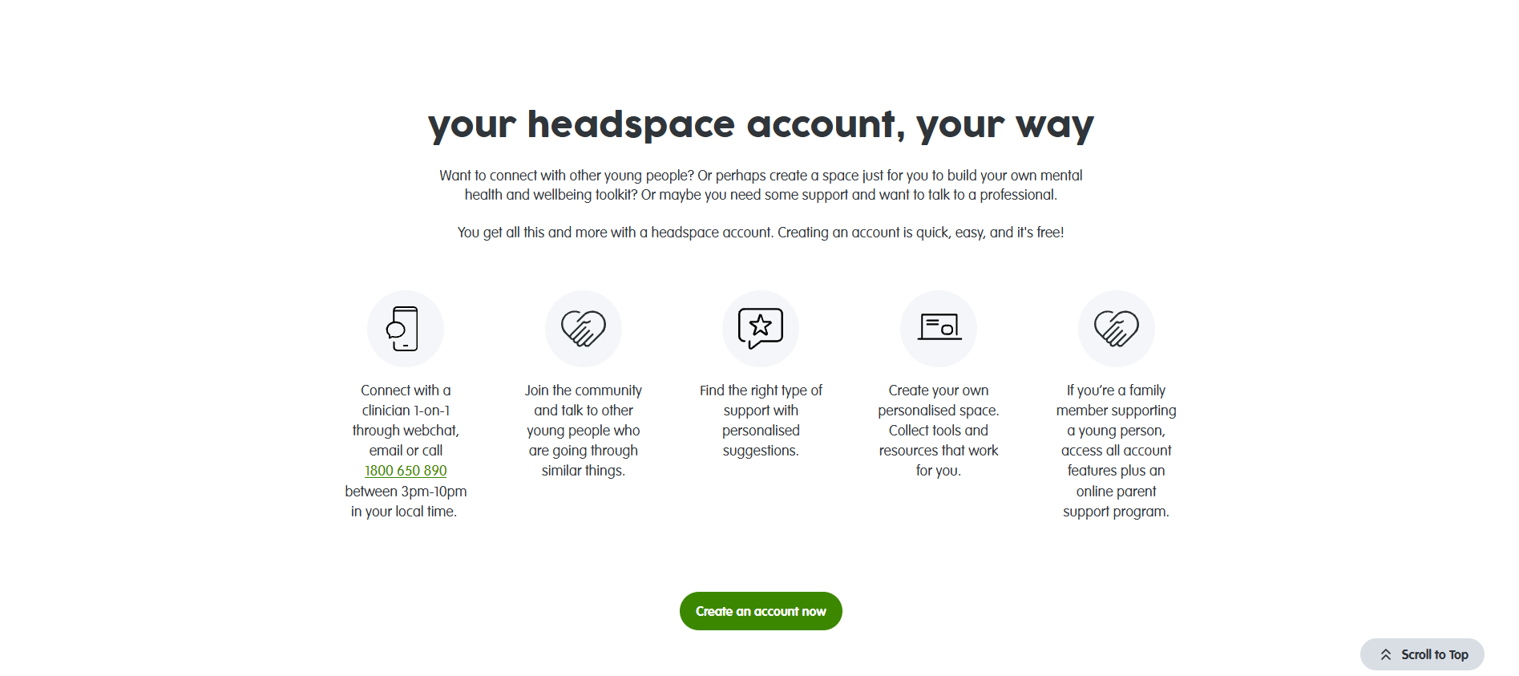 | - Focuses on youth mental health and who they are as an individual  - Talks about peer pressure, boundaries, and relationship's  - It's very clean and a very modern design website (applying to teens)  - Easy to read layout  - Break up the topics into manageable sections  - And encourage self-awareness | - Not New Zealand based  - Some information is quite general  - Not specifically focused on people pleasing  - Not interactive  - Some advice may feel repetitive | - Include boundary setting tips (very important for teens who are going through this feeling of being a people pleaser)  - Use clean, simple designs (soft colours, simple layout)  - Make the information less overwhelming
Psychology Today  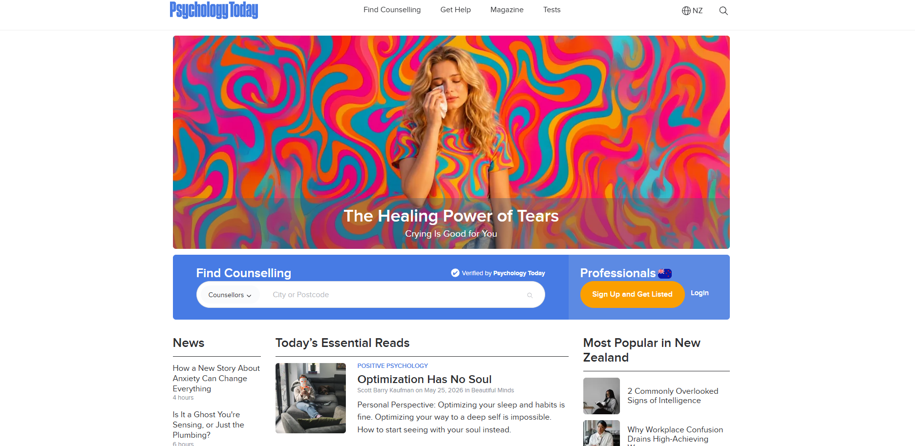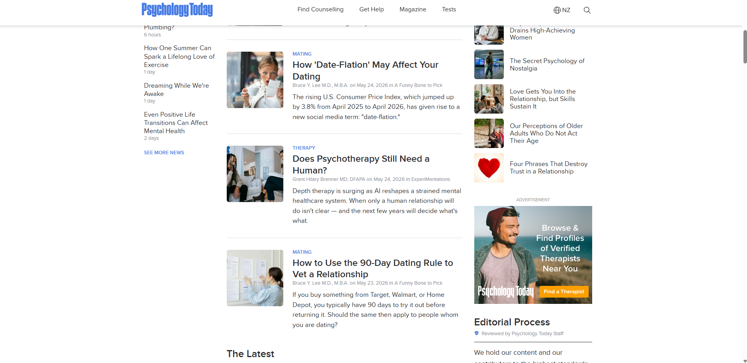 | - I like the way it is very detailed in explanations of people pleasing behaviour  - Explains the causes of people pleasing (fear of rejection, anxiety, low self-esteem)  - Written by professionals  - Covers behaviour patterns and the impacts  - Good for research and evidence | - The information can be too complex for the teens  - Not specifically aimed to the ages 15-19  - The articles provided can be too long and hard to read  - Not very visually engaging  - Some of the information may just be more suitable for “adults”. | - Create as “what is people pleasing?” section  - Add a “signs you may be a people pleaser” checklist  - Have explanations on why teens behave this way  - Include mental health impacts  (stress, burnout, anxiety)
CommonSense .com  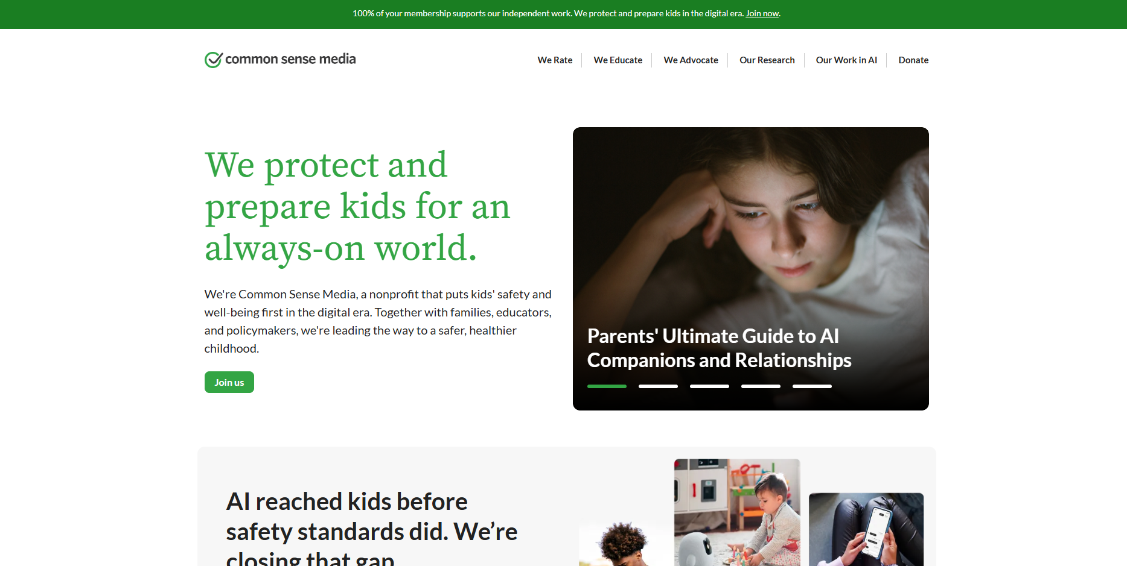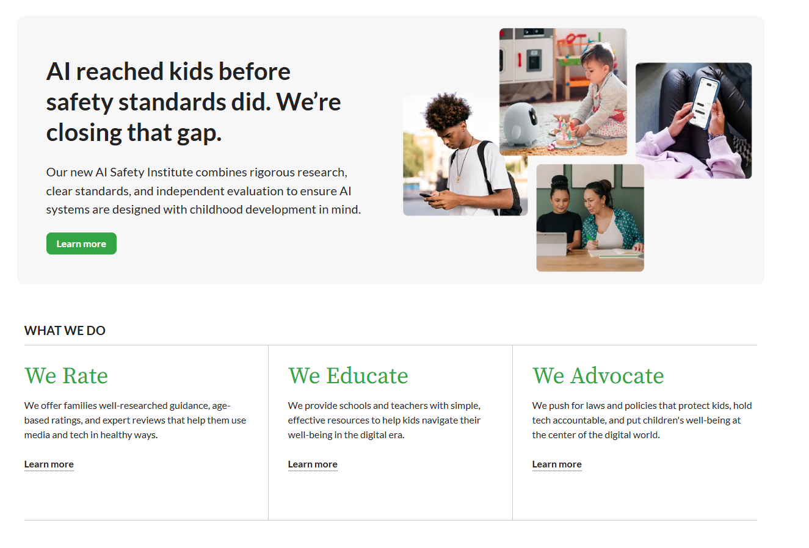 | - Focuses on teens and they digital life  - Explains what social media pressure and validation is  - Easy to read and understand  - Includes real life examples  - Connects they behaviour to online environments | - More focused on media than mental health  - Not specifically talking about the topic of people pleasing  - It is not NZ based but its US based information  - Not always detailed | - Link to people pleasing to social media behaviours  - Include some examples like:  - Liking posts to fit in  - Replying when you don't want to  - Agreeing online to avoid conflict  - Add engaging features like polls, scenarios and quizzes  - Make the information's relatable to a daily teen life
_{Context:}
My digital outcome that i focused on is about mental health and people pleasing. It is made to help teenagers and young people to understand how always trying to make others happy can affect their emotions, stress, confidence, and wellbeing. This digital outcome could be used in schools, youth groups, counselling, or spreading awareness about mental health online. It will be designed to understand, relatable, and support young people who struggle with saying no, setting boundaries, or putting to much pressure on themselves to please others. The purpose of this outcome is to educate, support, and encourage positive mental health by sharing advice and ways to build self-confidence.
_{End User Requirements:}
Because my target users are teenagers aged 15-19, the digital outcome must be simple, clear, and easy to understand. It should have a calm but engaging design with clear headings, short paragraphs, and visuals to keep the users interested. The outcome should be supportive, so users feel comfortable learning about mental health and people's pleasing. It must also include accurate information and coping strategies to help users understand healthy boundaries and self-care. In addition, the digital outcome should be easy to access and work well on different devices such as phones, tablets, and laptops. These requirements will help users feel supported, safe, and engaged while using different digital outcomes.
Part 2: Investigate relevant user experience methodologies.

USER EXPERIENCE ( ux ) Methodologies
To make my website effective for teenagers aged 15-19, i will be using different user experience (ux) methodologies to understand what users want and need from the website. This includes user research, observations, information architecture, and accessibility. These methods will help me create a website that is supportive, visually appealing, and easy to use.

USER RESEARCH

For this assessment, I carried out informal interviews with teenagers within the target age group where i gathered ideas on what they expect to see from a mental health website on people pleasing. I asked questions about colours, layout, features, and what type of content would keep them interested.
Here are some of the suggestions they have requested:
- 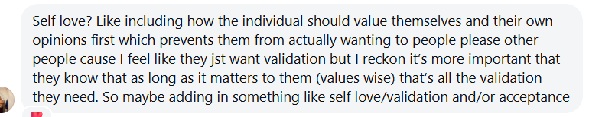
(testimonies, cards of affirmation and validation)
- 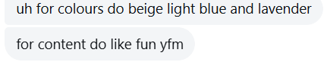

This feedback has helped me understand what teenagers find engaging and comfortable when using websites related to topics like People pleasing and mental health.

OBSERVATIONS
From my observations, teenagers spend most of their time on devices, social media, and websites that contain visual and interactive content. Because of this, my website will include features like images, icons, quizzes, and short sections of information to make the content easier to understand and more engaging. Teenagers are most likely to stay on the website if it feels modern, relatable, and visibly calm. Including supportive messages and relatable situations can also help the users feel understood and connected through the website.

INFORMATION ARCHETICTURE
This part focuses on
- How content is designed?
- How its presented clearly to users
My website will use a clear navigation bar and organized sections where users can easily move through the website and find information quickly. Pages such as Home, About, Quizzes, Support, and Contact will help organize information in a simple and designed way to reduce visual stress.

MINIMALIST DESIGN
When deigning my website i will adjust the layout to where it can avoid clustered layouts, long paragraphs and the use of too many bright colors. Instead, the website will include clean sections and short texts. This is important because if there is too much information it makes them feel overwhelmed, especially for users learning mental health topics such as stress, anxiety, and people pleasing.

CONSISTENCY AND COLOR PALLETE
Consistency will be the key design principle applied throughout the website to ensure it creates a smooth and easy user experience. This will be Achieved by keeping the same fonts, colors, spacing, and navigation bar on every page. This helps create a clear visual structure and makes the website easier to use because users know what to expect on every page. Which also helps reduce confusion and makes the website more organized and professional. To support this, the website will use a soft pastel color pallet. These colors were chosen because they create a calm and welcoming feeling, which is suitable for teenagers aged 15-19. The colors will be low in brightness and not overwhelming, helping to create a relaxing and supportive environment.

ACCESIBILTY
To improve accessibility the website will be designed to
- work on phones, iPad, and laptops using a responsive layout
- Readable fonts, clear headings, and good contrast between texts and background colors will also help make the website easier to use.
- Images and icons will help support written information for users who prefer visual learning styles.
Part 3: Applying user experience methodologies to generate a range of design ideas.
- From my user research, including other feedback that was given back from teenagers ages 15-19, I've learned that they prefer to have websites that are calm, easy to read, and not too wordy. They like visual things like pictures, short videos, and real-life examples they can relate to. They also seem to enjoy Quizzes and helpful content that explains people's pleasing and mental health clearly.
- Based on information architecture, I focused on making the website easy to navigation using simple designs with short text and less clustered, so users don't feel overwhelmed. Consistency helped me keep the fonts, Colors, Layout, and menu on every page. This makes the website easier to use and more comfortable for users.
- Accessibility helped my design by making sure the website works on all devices. I also used clear headings and easy to read text so every can understand the content easily.
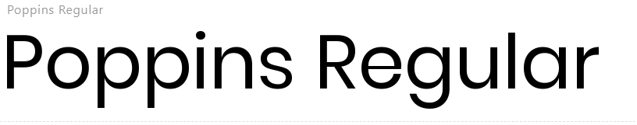
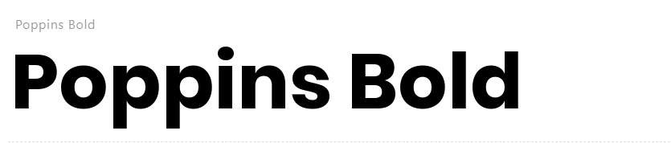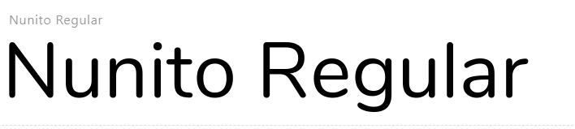
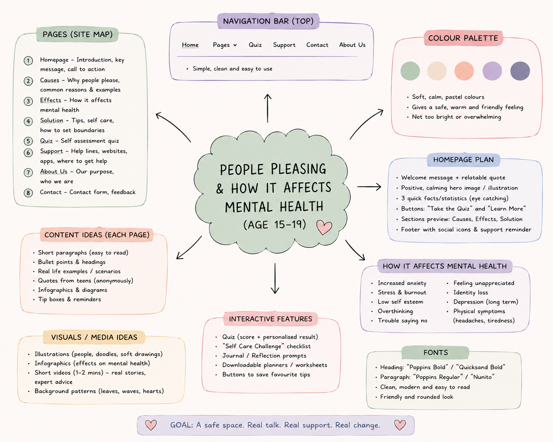

Part 4: Explaining the appropriateness of a chosen design. (Low Fidelity).
Design 1 | Design 2 | Design 3
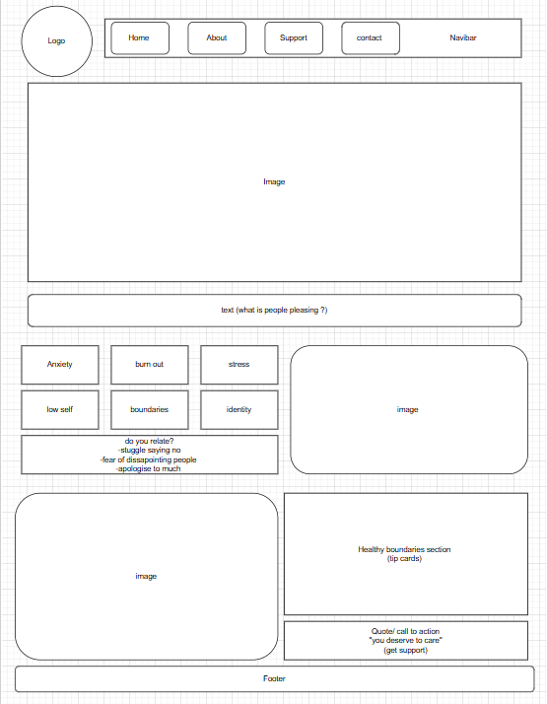 | 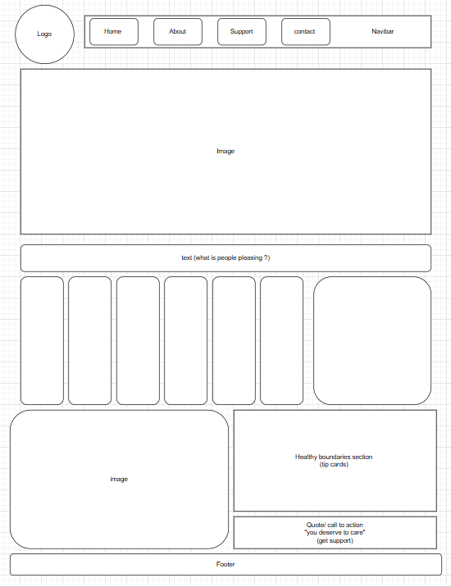 | 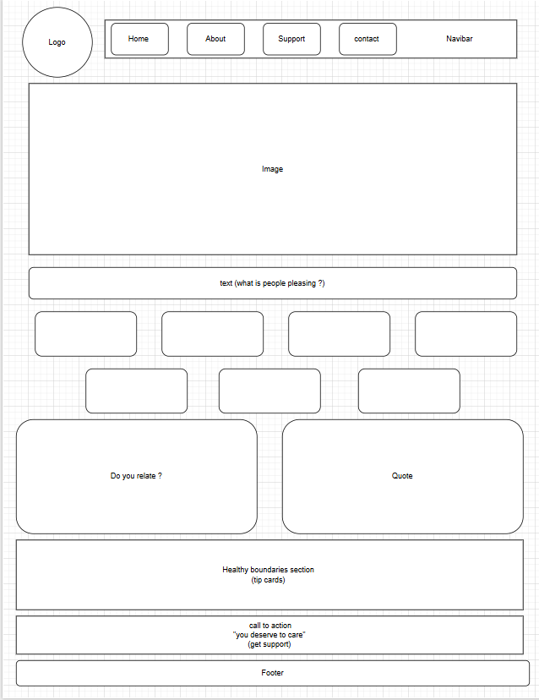
To confirm which layout would be best to do that I have asked a couple of students and friends what's their thoughts on the 3 layouts, this was their feedback:
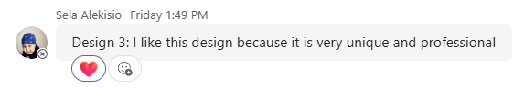
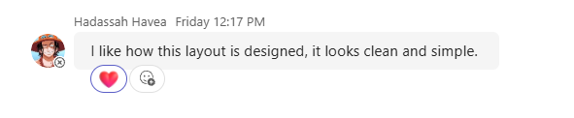
(she replied to Design 3)
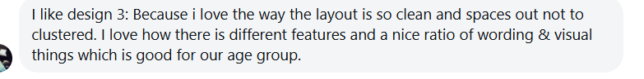
This is their feedback: three people gave feedback, and all of them liked design 3. Two of them, Raisa and Boy, said during class that they preferred design 3 because it looked the most attracted and well organized. Because everyone agreed on design 3, I decided to continue with it as my final choice

Part 5: Modelling and testing the design idea. (The mock-up or high fidelity).
Design 1 | Design 2 | Design 3
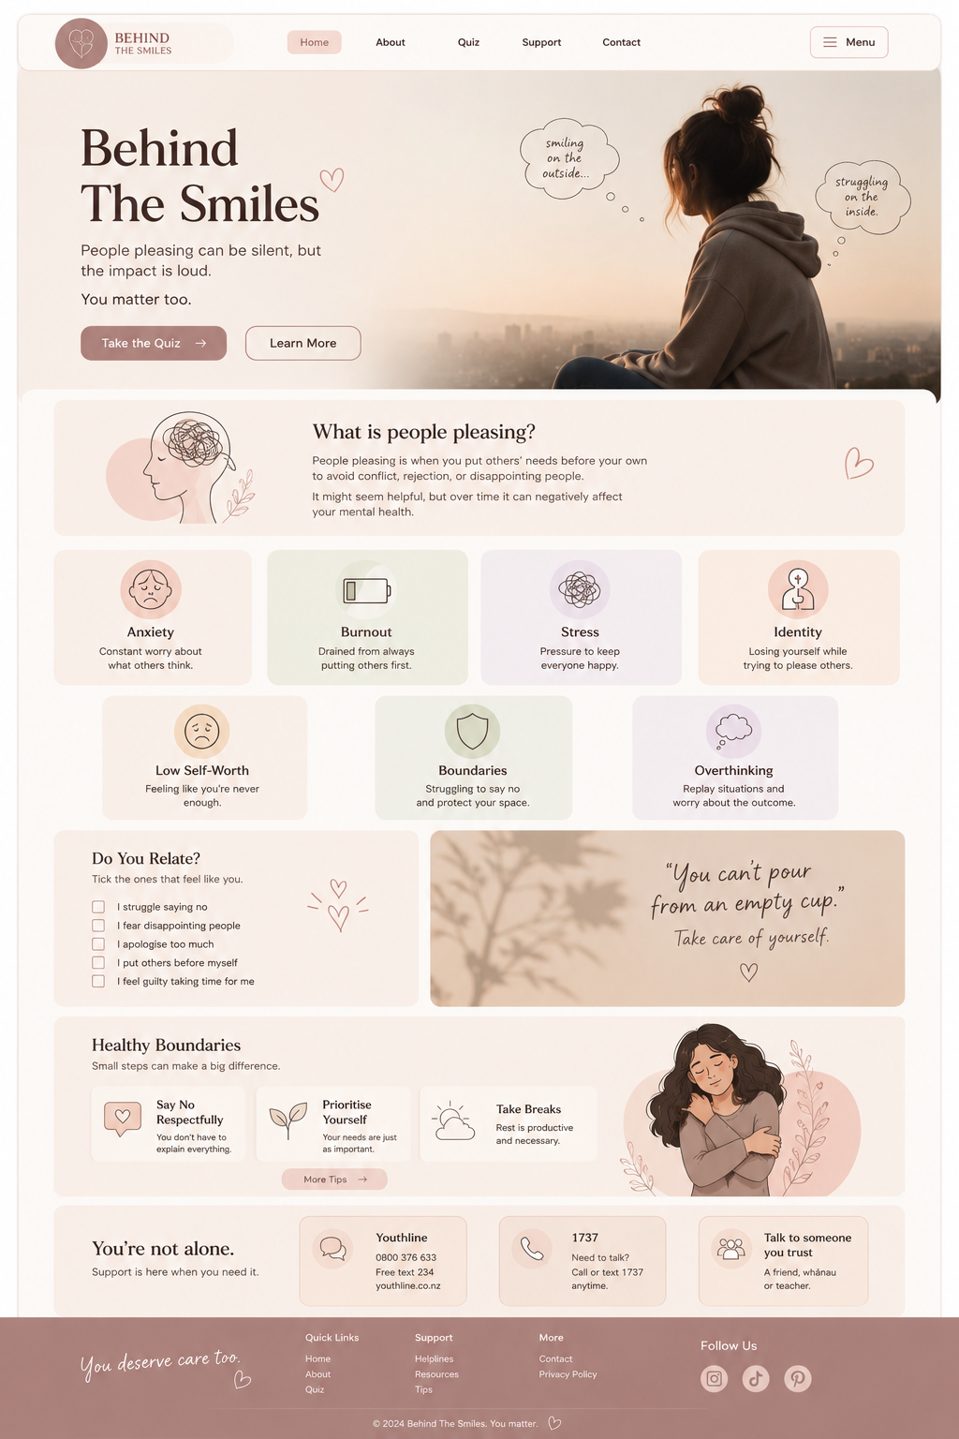  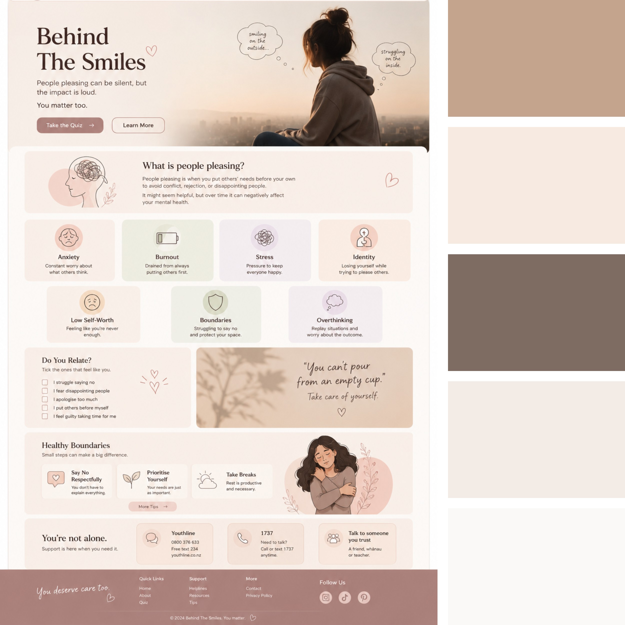 | 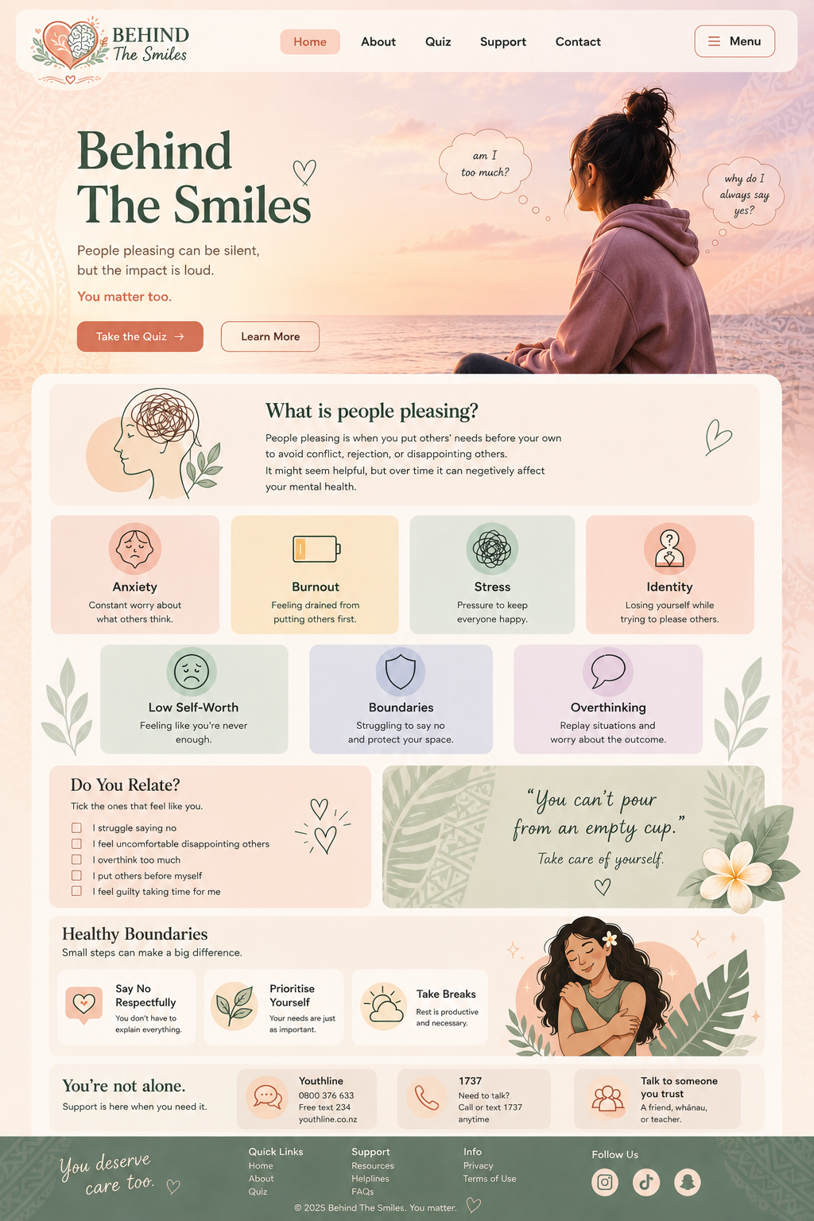  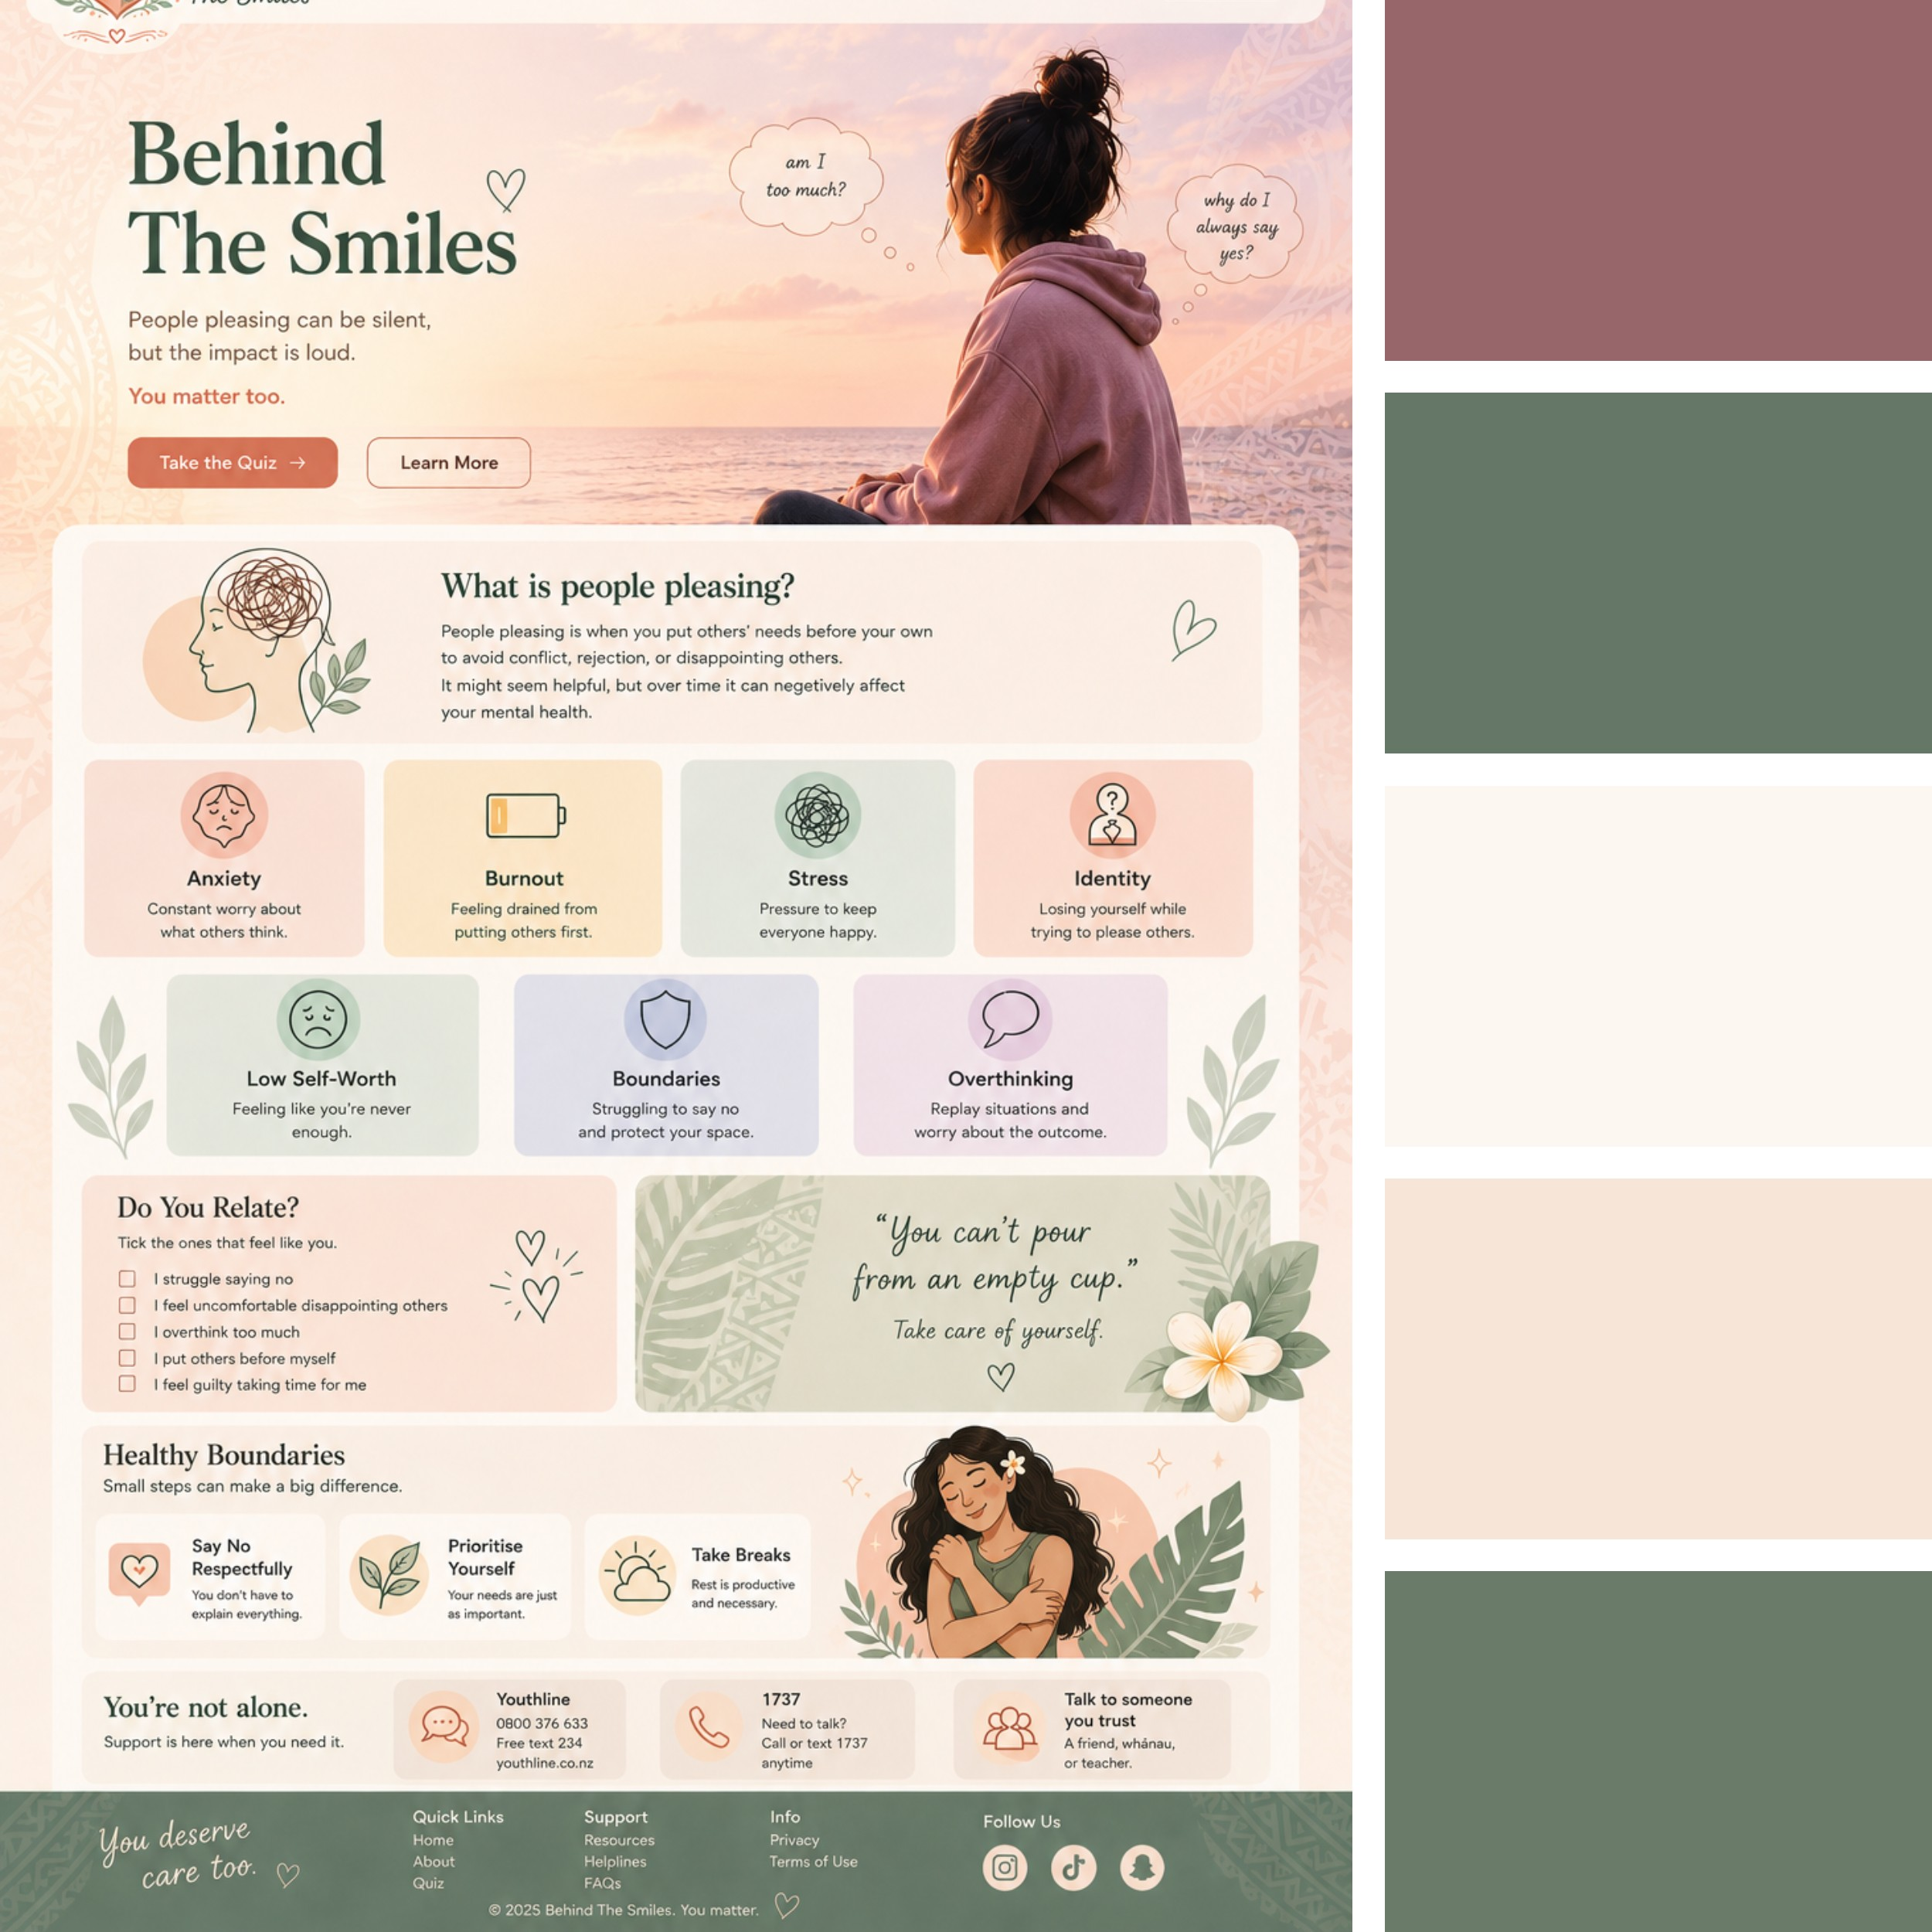 | 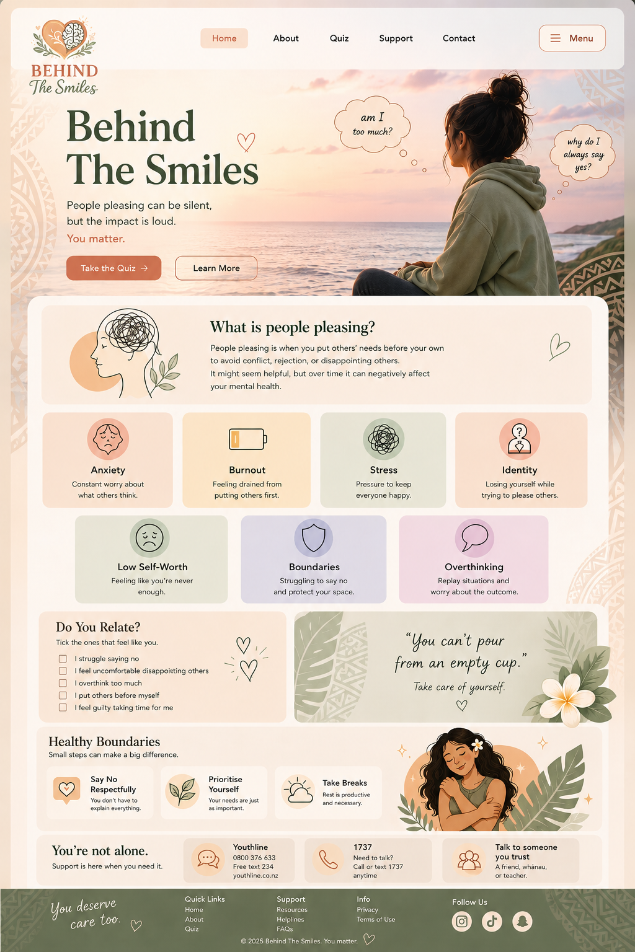  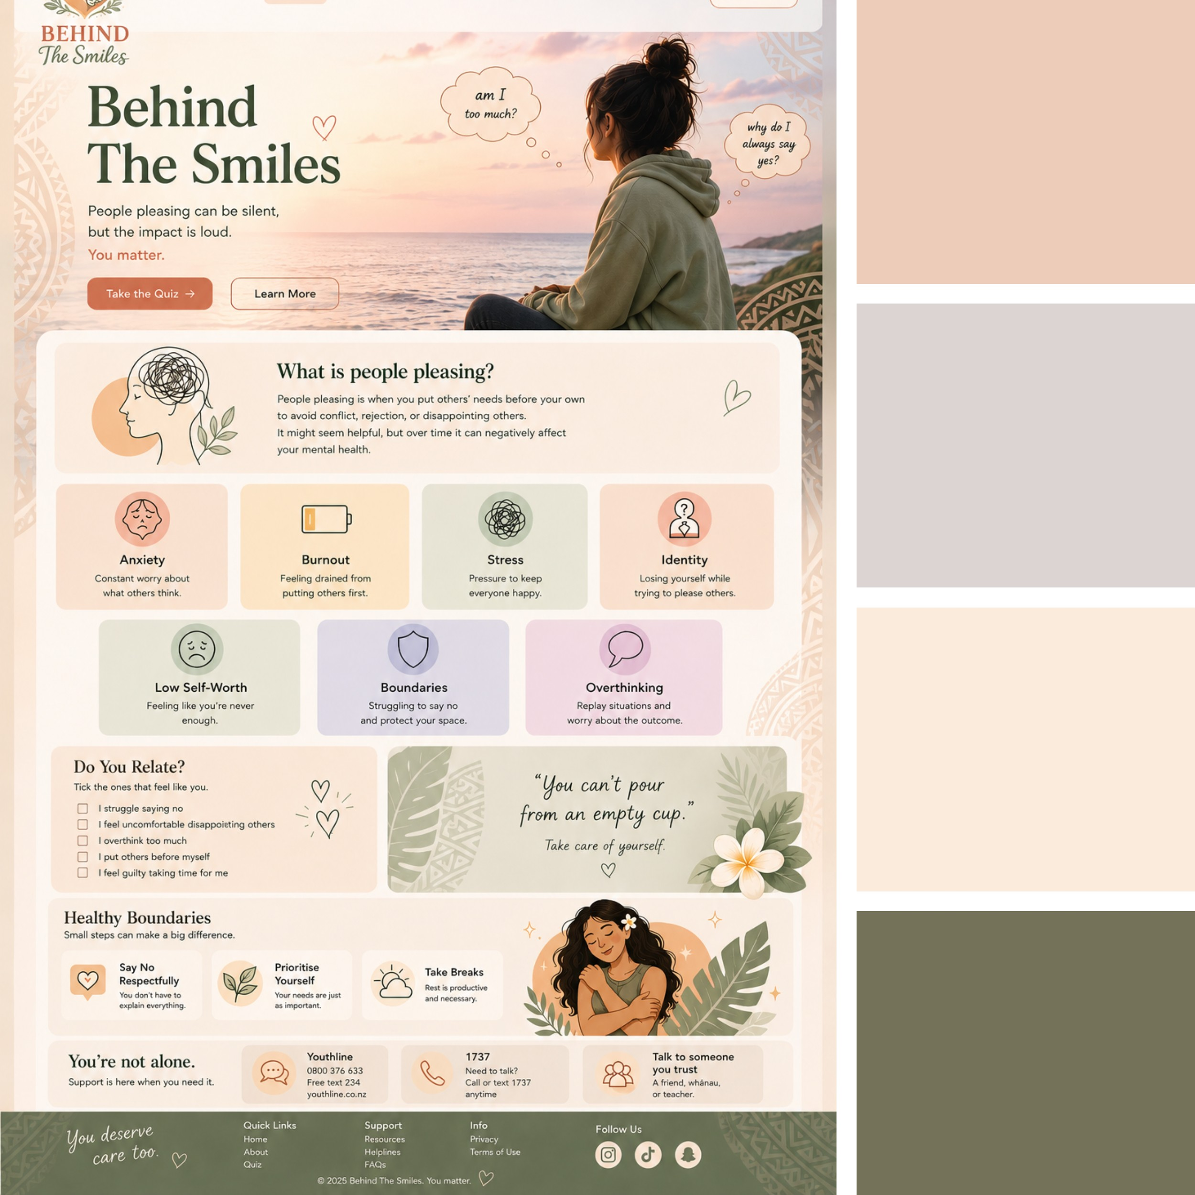
To confirm which color would be best to do for the website, I have asked a couple of students and friends what's their thoughts on the 3 layouts, this was their feedback:
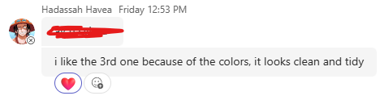
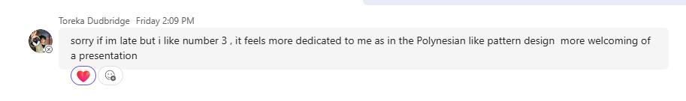
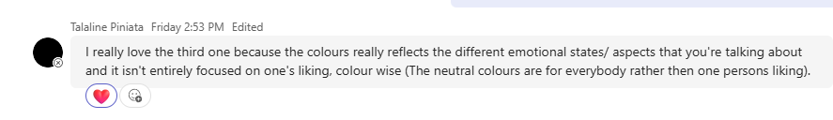
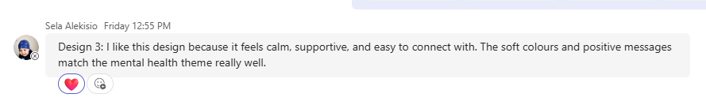
All these students are around 16-17 years old, which is the age range I’m aiming for. This feedback is all preferred design 3. Which was the final decision.

Part 6: Explain relevant implications.
When I designed the layout of my website about people pleasing and how it affects mental health, i had to follow important design principles to meet the relevant implications of: accessibility, aesthetics, and the end user. These were chosen to help me design my website to be supportive, welcoming, and easy to use for teenagers aged 15-19. Every choice, from color and layout to the features that were added, was to create a safe space for teenagers to learn more about people's pleasing and mental health.
Accessibility
For the website to meet the accessibility requirements, I made sure that there I used clear headings, readable fonts, and good colors so users can read the information easily. I also added simple navigation buttons and a clean layout, so users do not get confused on the website. This website is also responsive meaning it could be used on phones, Tablets, iPad, and computers. Images can also include texts so people who cannot see the images clearly can still understand what the picture shows.

Aesthetics'
To meet the aesthetic requirements, I used soft pastel colors like cream, sage green, beige, and dusty pink to create a calm and welcoming space for teenagers when using the website. I made the website clean so it's a not so overcrowded, using short paragraphs, Images, and the spacing to keep it organized. The fonts and headings I use are kept consistent throughout the website, making it neat and easy to follow. With this modern design it helps teenagers feel safe while learning about people-pleasing and mental health.

End user
To support the needs of the end users, I made the website interactive and suitable for teenagers aged 15-19 to use. I used features such as quizzes, relatable quotes, Checklist, and a support section to make sure the users feel engaged and understood. I also used simple languages, so the information provided is easy to understand. The use of calming colors, relatable images, and supportive messages/quotes make the website feel safe and helpful for young people struggling with people-pleasing and mental health.
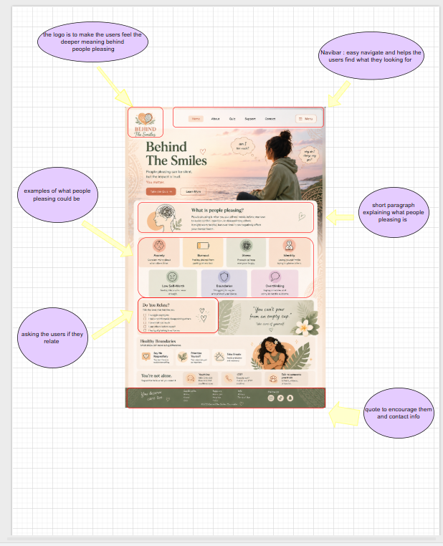

https://www.nzcer.org.nz/blogs/fear-failure-regret-and-getting-past-survival-reactions#:~:text=I%20wish%20I%20had%20stayed,to%20be%20in%20the%20world.

